Bevel Gauge
# Source: AI Source: Provided by: [Data Path: Persons Table -> ID Column: 1, Name_En Column: Motasem Essam] -> From: [ChatGPT] on [7/17/2026]
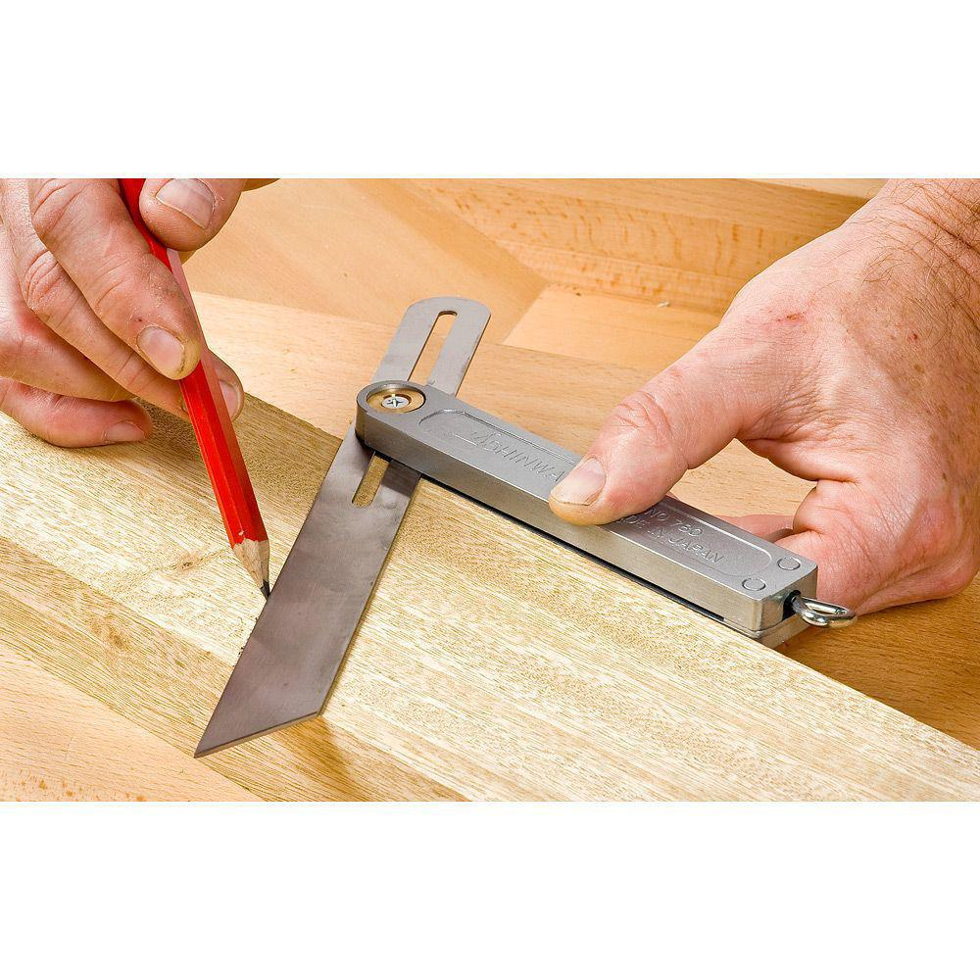
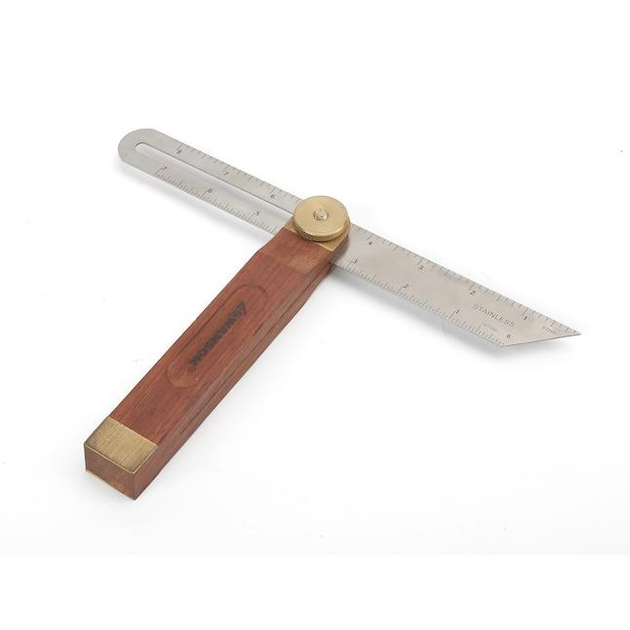
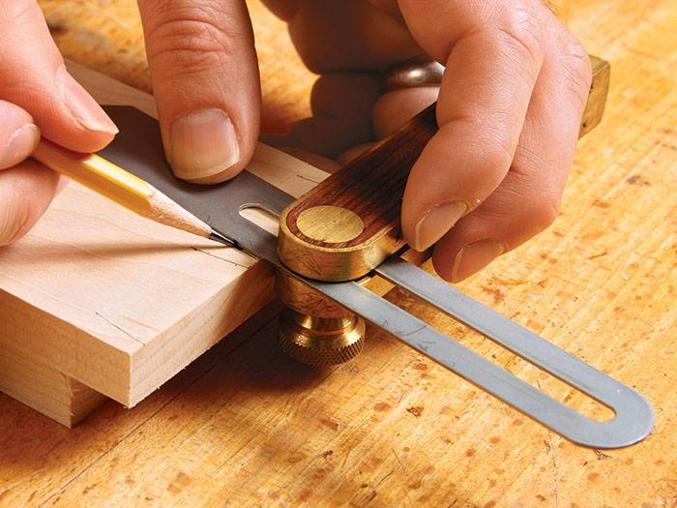
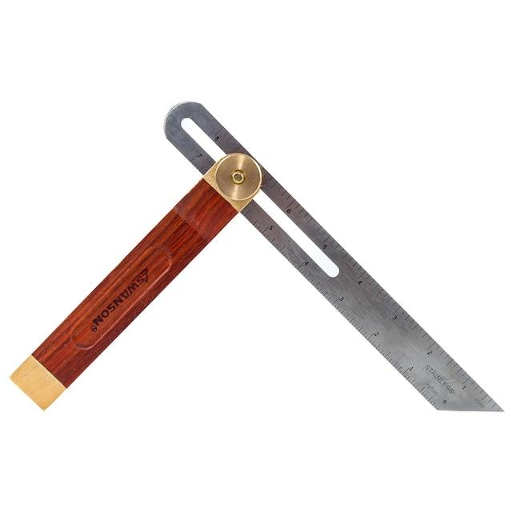
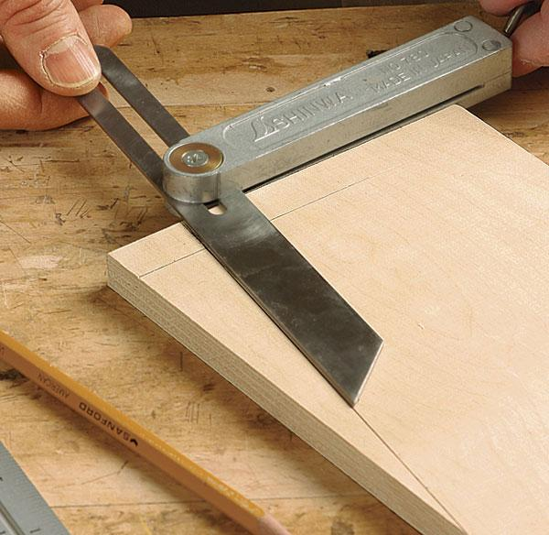
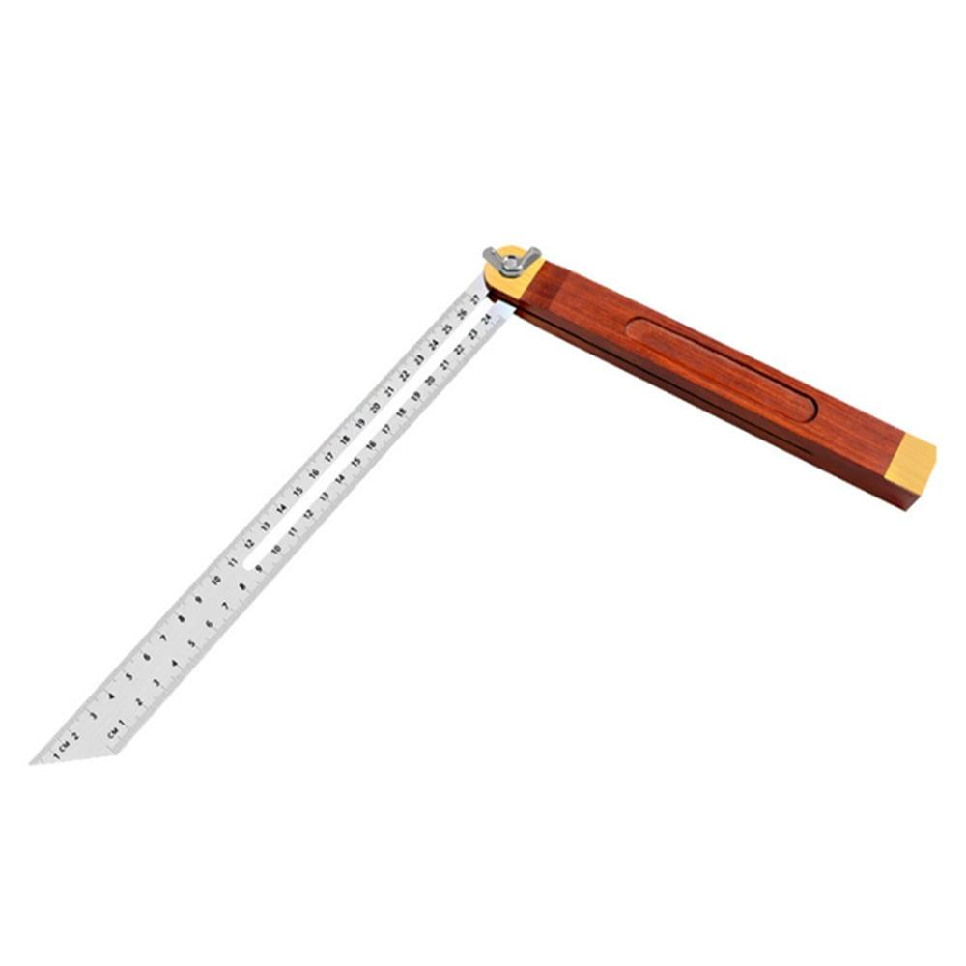
A Bevel Gauge (also called a Sliding Bevel, Bevel Square, or Adjustable Bevel) is an adjustable angle-measuring and angle-transferring instrument used to copy, transfer, and mark angles. Unlike a protractor, a standard bevel gauge does not have a graduated scale; it is used to replicate an existing angle or transfer an angle that has been set using another instrument.
Bevel gauges are widely used in carpentry, woodworking, machining, metalworking, engineering, construction, and drafting.

Definition
# Source: AI Source: Provided by: [Data Path: Persons Table -> ID Column: 1, Name_En Column: Motasem Essam] -> From: [ChatGPT] on [7/17/2026]
A Bevel Gauge is an adjustable measuring and layout tool consisting of a handle and a pivoting blade, used to copy, transfer, and mark angles without directly measuring them.

Purpose
# Source: AI Source: Provided by: [Data Path: Persons Table -> ID Column: 1, Name_En Column: Motasem Essam] -> From: [ChatGPT] on [7/17/2026]
A Bevel Gauge is used to:
- Copy existing angles.
- Transfer angles from one workpiece to another.
- Mark angled lines.
- Set machine or tool angles.
- Assist in layout work.
- Verify angular relationships.

Principle of Operation
# Source: AI Source: Provided by: [Data Path: Persons Table -> ID Column: 1, Name_En Column: Motasem Essam] -> From: [ChatGPT] on [7/17/2026]
A bevel gauge works by:
- Loosening the locking mechanism.
- Rotating the blade to match the required angle.
- Locking the blade in position.
- Using the fixed angle as a template to mark or compare other parts.

Main Components
# Source: AI Source: Provided by: [Data Path: Persons Table -> ID Column: 1, Name_En Column: Motasem Essam] -> From: [ChatGPT] on [7/17/2026]
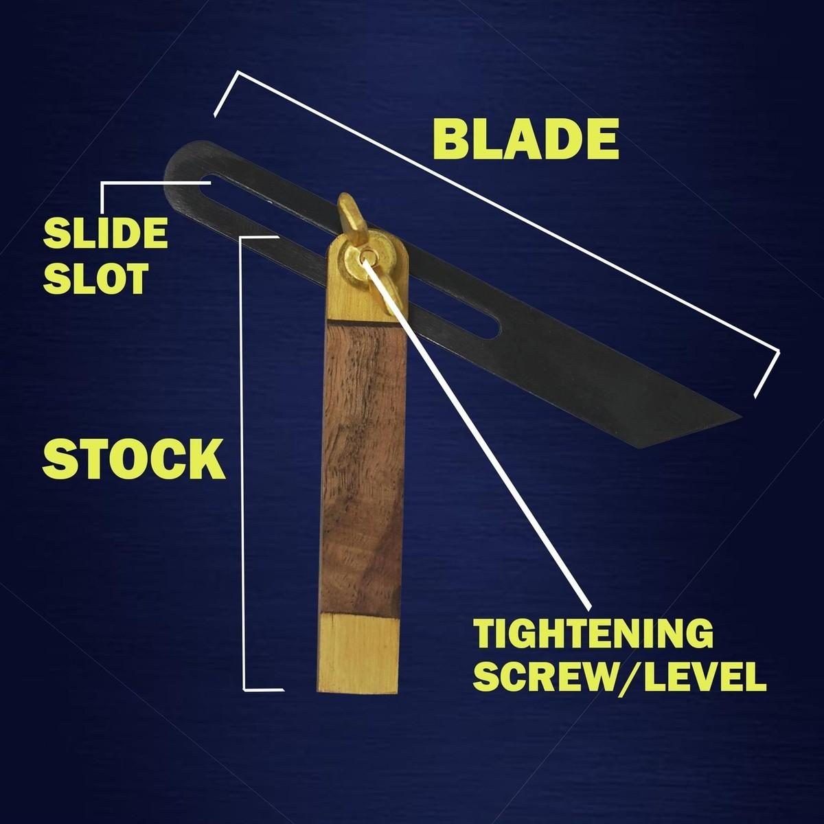
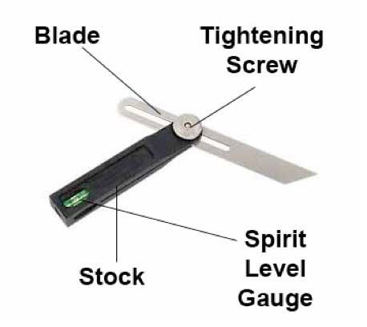
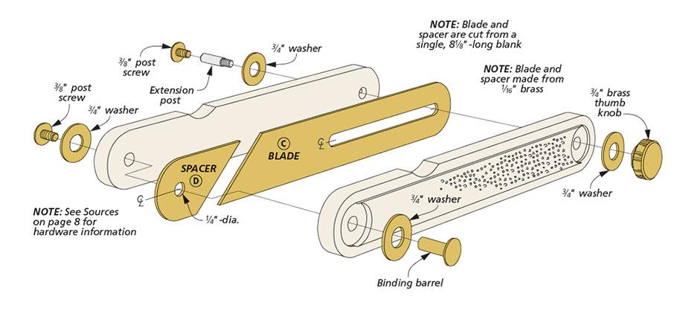
A typical Bevel Gauge consists of:
- Handle (Stock)
- Adjustable Blade
- Pivot Joint
- Locking Screw or Wing Nut

Types of Bevel Gauges

1. Standard Sliding Bevel Gauge
# Source: AI Source: Provided by: [Data Path: Persons Table -> ID Column: 1, Name_En Column: Motasem Essam] -> From: [ChatGPT] on [7/17/2026]

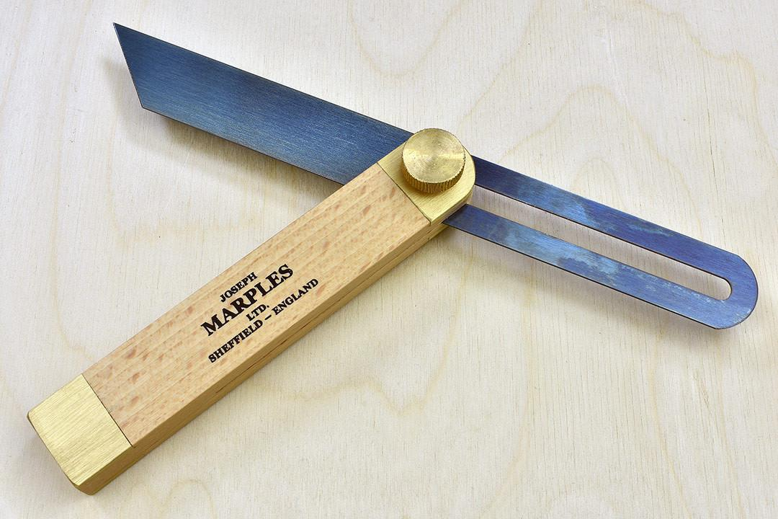
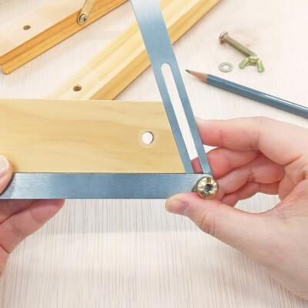

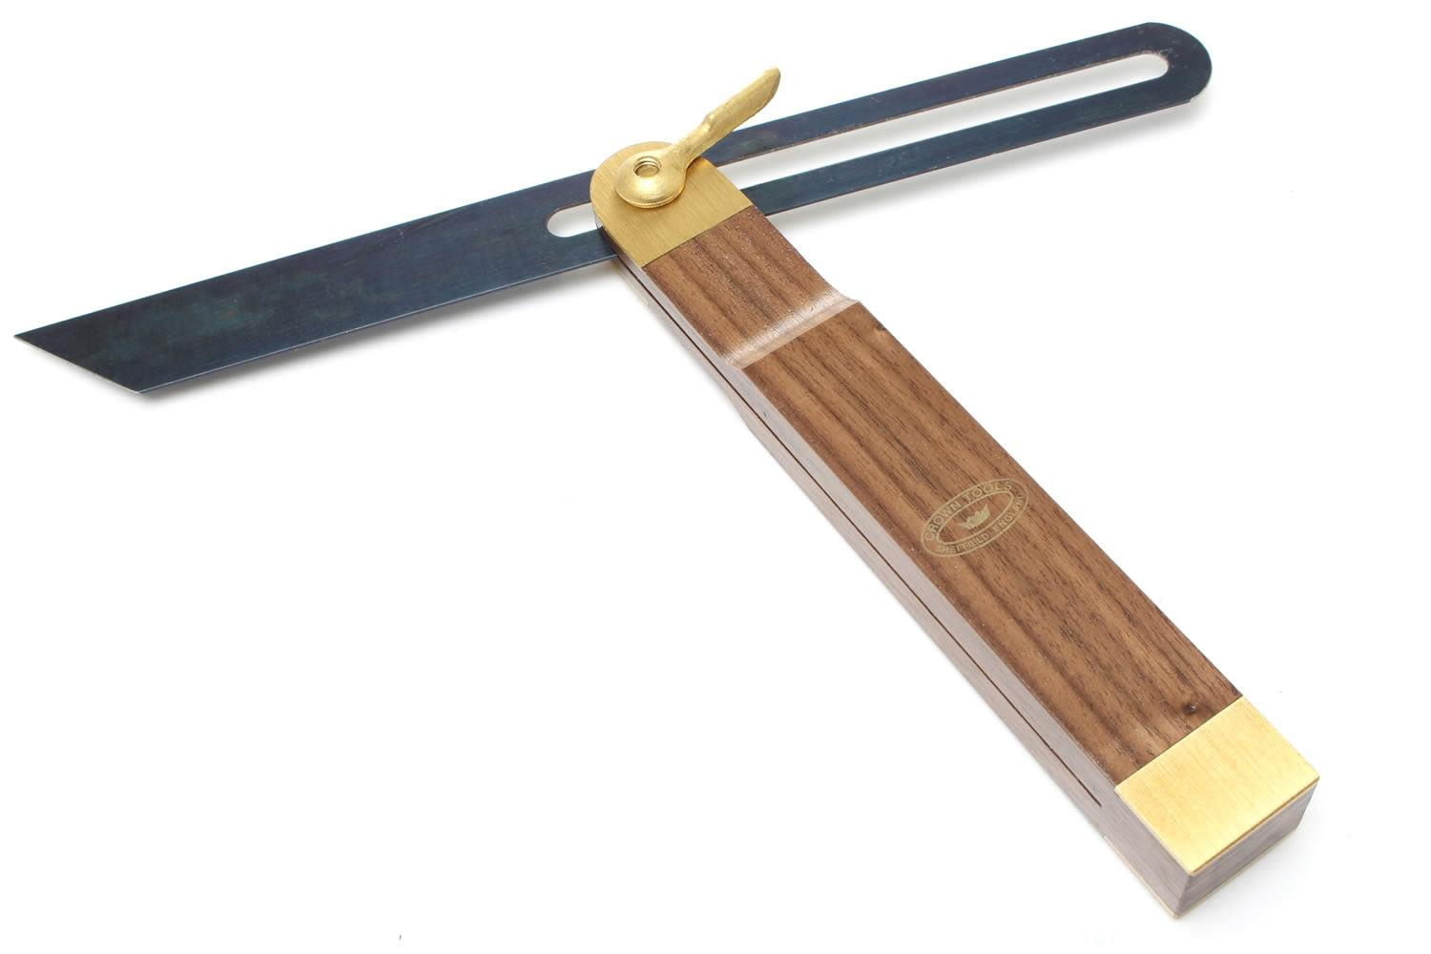
Description
The most common type, featuring a movable blade that locks at any desired angle.
Applications
- Carpentry
- Woodworking
- General layout work
- Construction

2. Digital Bevel Gauge
# Source: AI Source: Provided by: [Data Path: Persons Table -> ID Column: 1, Name_En Column: Motasem Essam] -> From: [ChatGPT] on [7/17/2026]
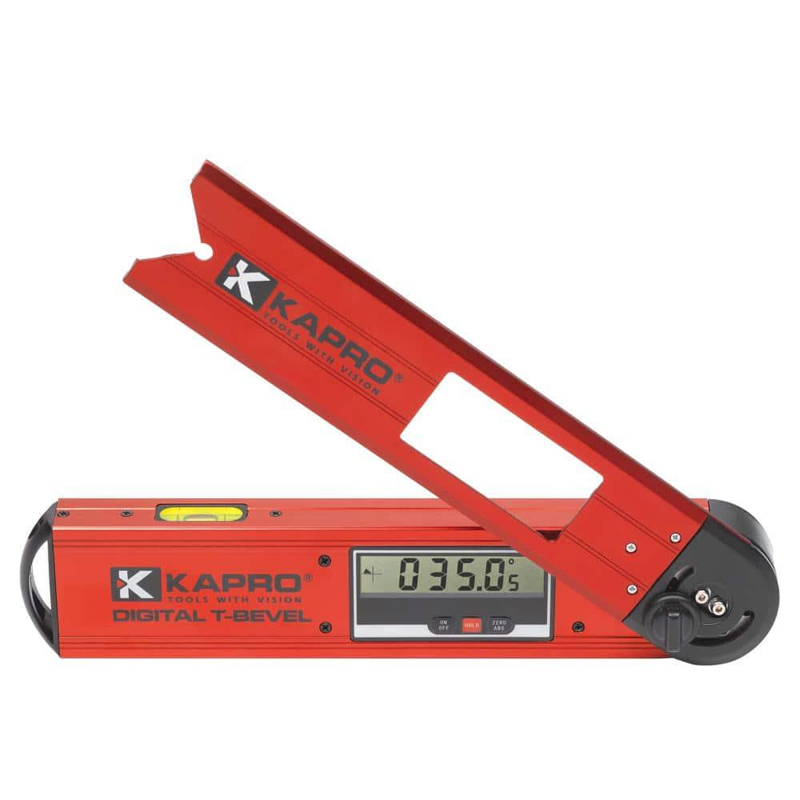
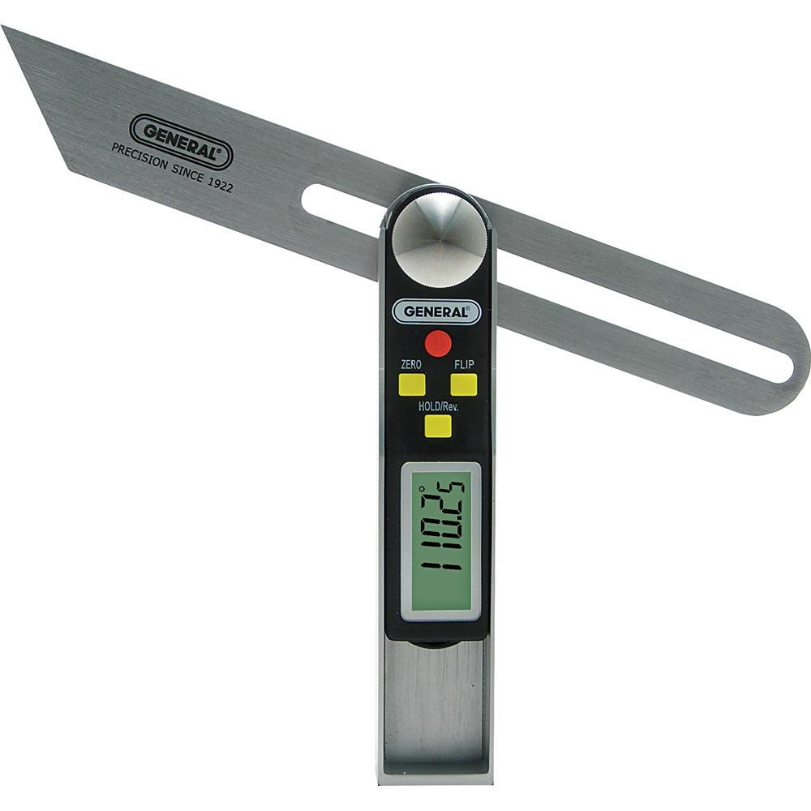
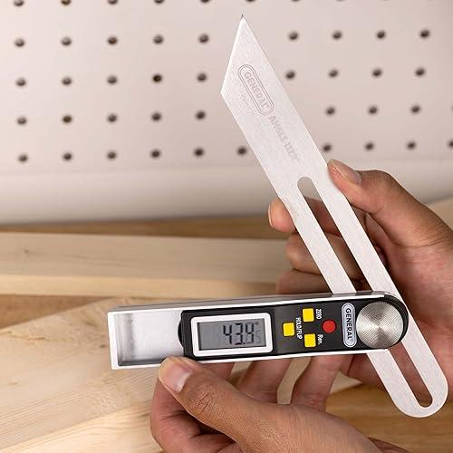
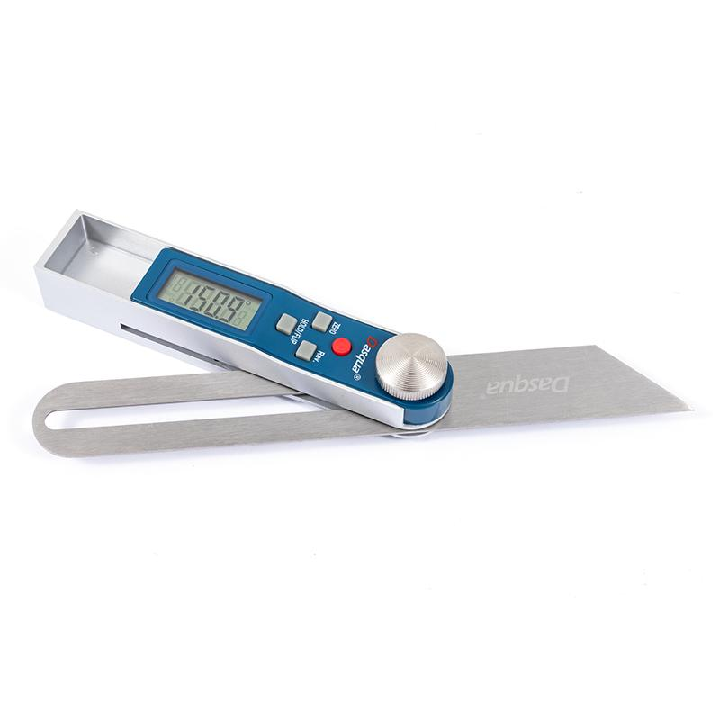
Description
An electronic version with an LCD display that directly shows the measured angle.
Features
- Digital display
- High precision
- Zero setting
- Angle hold function
Applications
- Precision engineering
- CNC setup
- Machine alignment
- Quality inspection

3. Universal Bevel Gauge
# Source: AI Source: Provided by: [Data Path: Persons Table -> ID Column: 1, Name_En Column: Motasem Essam] -> From: [ChatGPT] on [7/17/2026]
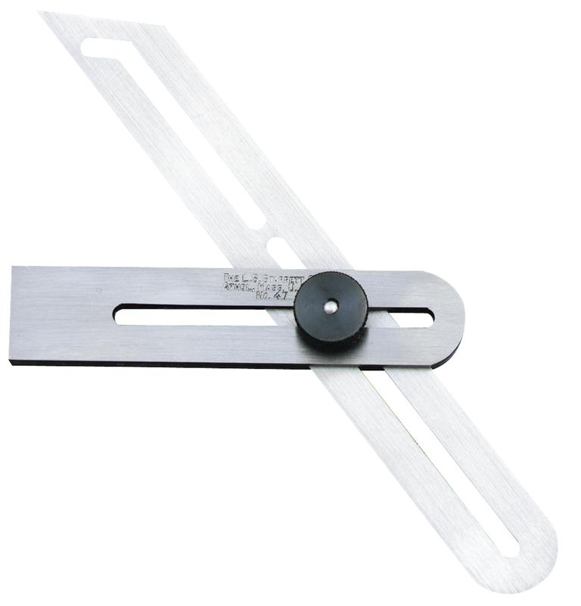
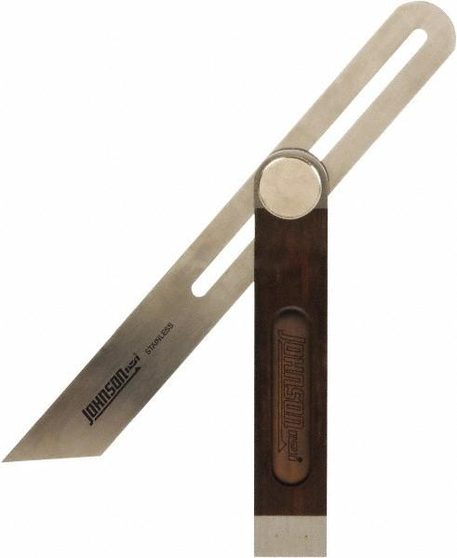
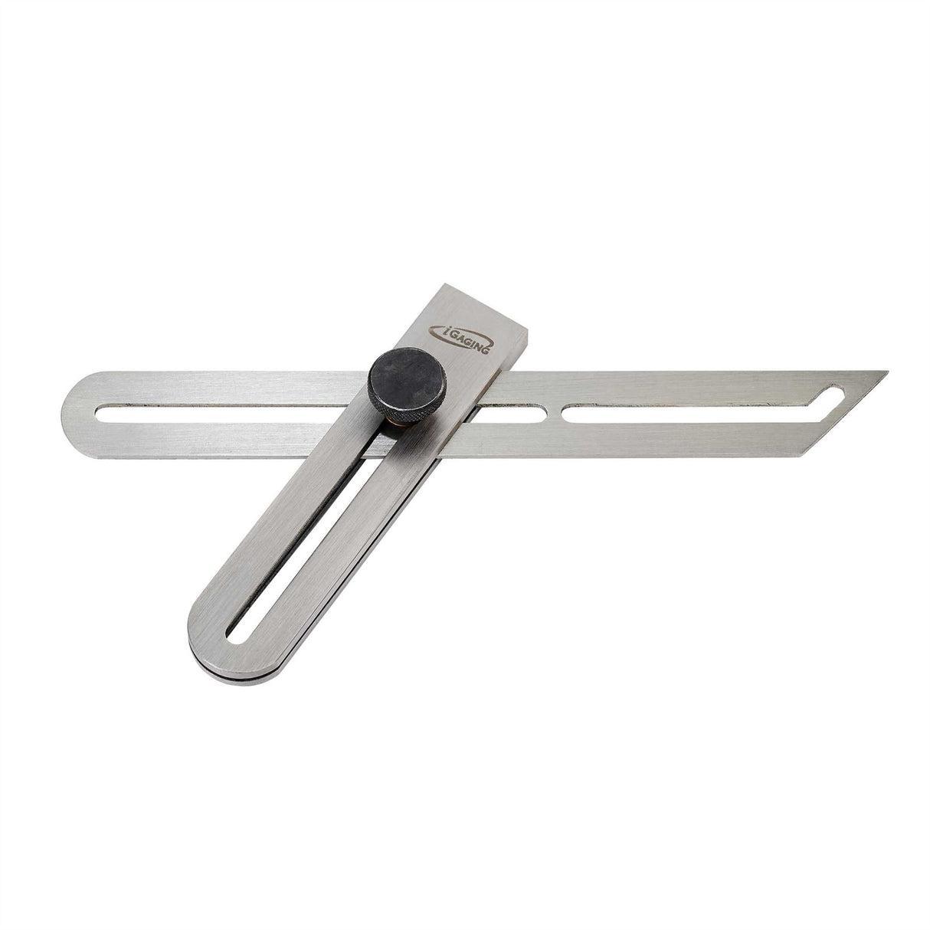
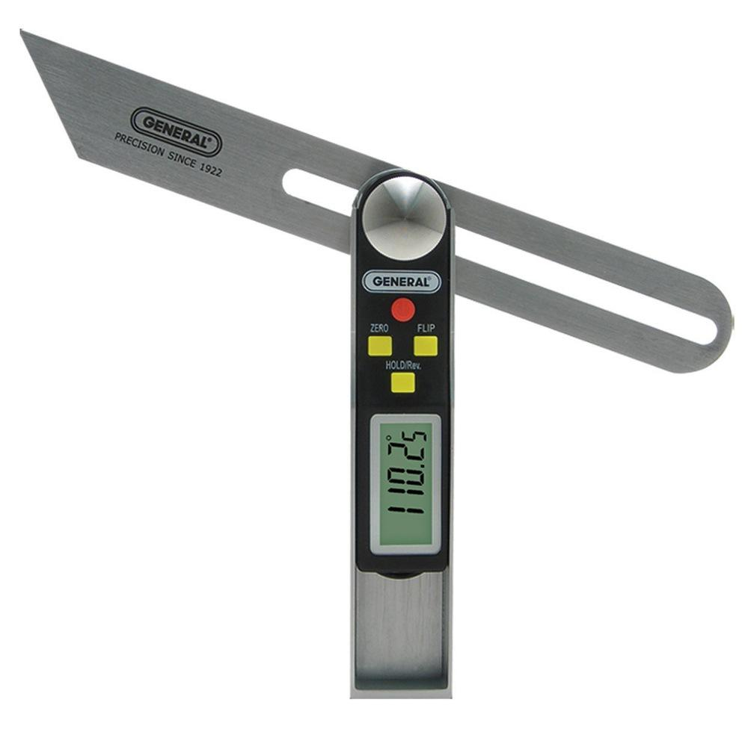
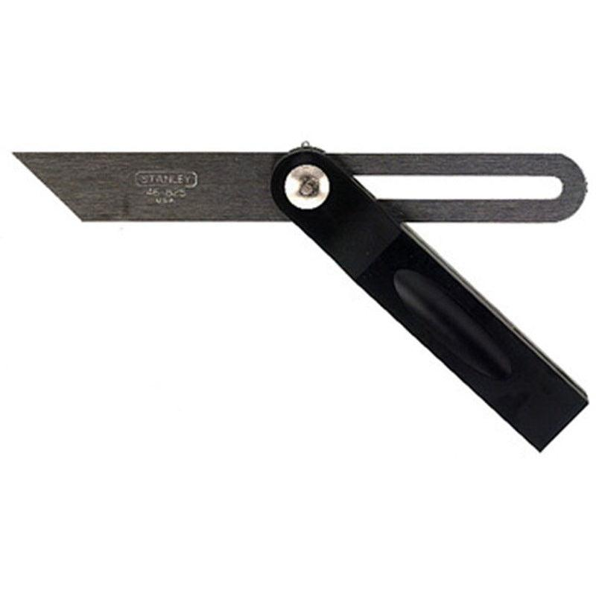
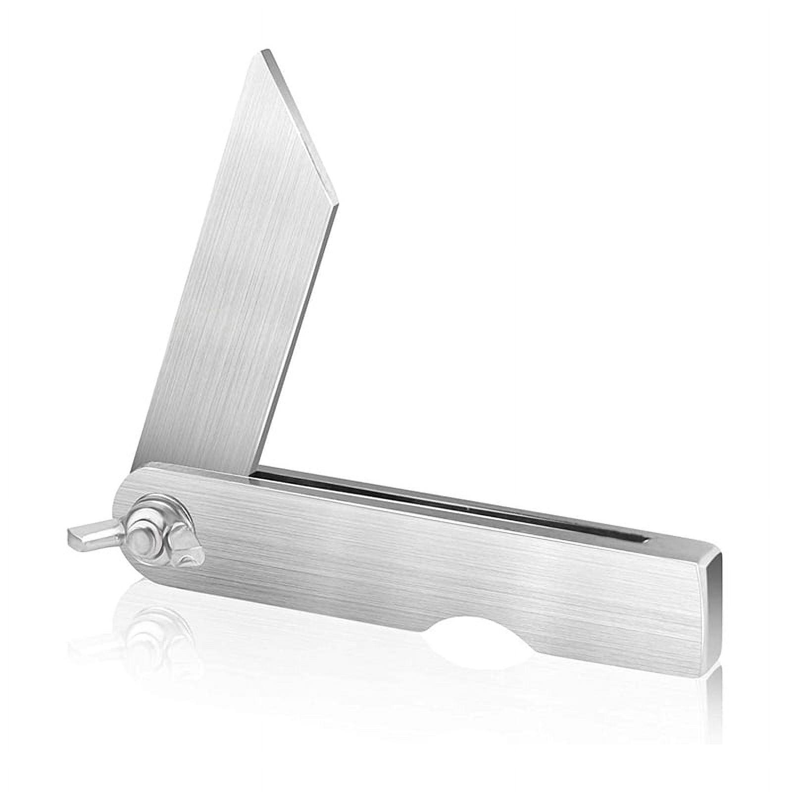
Description
A high-precision bevel gauge used in engineering workshops, often combined with a graduated scale or vernier mechanism for accurate angle measurement.
Applications
- Precision machining
- Tool rooms
- Metrology
- Mechanical engineering

Measuring Range
# Source: AI Source: Provided by: [Data Path: Persons Table -> ID Column: 1, Name_En Column: Motasem Essam] -> From: [ChatGPT] on [7/17/2026]
Most bevel gauges can be adjusted through:
- 0°–360°

Resolution
# Source: AI Source: Provided by: [Data Path: Persons Table -> ID Column: 1, Name_En Column: Motasem Essam] -> From: [ChatGPT] on [7/17/2026]
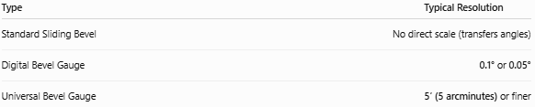
Type | Typical Resolution
Standard Sliding Bevel | No direct scale (transfers angles)
Digital Bevel Gauge | 0.1° or 0.05°
Universal Bevel Gauge | 5′ (5 arcminutes) or finer

How to Use a Bevel Gauge
# Source: AI Source: Provided by: [Data Path: Persons Table -> ID Column: 1, Name_En Column: Motasem Essam] -> From: [ChatGPT] on [7/17/2026]
- Loosen the locking screw.
- Rotate the blade until it matches the required angle.
- Tighten the locking screw securely.
- Place the gauge against the workpiece.
- Mark or compare the angle.

Example
# Source: AI Source: Provided by: [Data Path: Persons Table -> ID Column: 1, Name_En Column: Motasem Essam] -> From: [ChatGPT] on [7/17/2026]
A protractor measures an angle of 37°.
The bevel gauge blade is adjusted to match 37°, locked in position, and then used to transfer that angle to another workpiece without needing to measure it again.

Accuracy
# Source: AI Source: Provided by: [Data Path: Persons Table -> ID Column: 1, Name_En Column: Motasem Essam] -> From: [ChatGPT] on [7/17/2026]
Typical accuracy depends on:
- Blade rigidity
- Pivot quality
- Locking mechanism
- Operator technique
- Calibration (digital or universal models)

Sources of Error
# Source: AI Source: Provided by: [Data Path: Persons Table -> ID Column: 1, Name_En Column: Motasem Essam] -> From: [ChatGPT] on [7/17/2026]
Instrument Errors
- Loose pivot
- Bent blade
- Worn locking mechanism
- Manufacturing defects

Observation Errors
- Incorrect alignment with the reference angle
- Reading the digital display incorrectly (digital models)

Positioning Errors
- Blade slipping before locking
- Incomplete contact with the workpiece
- Incorrect transfer of the angle

Environmental Errors
- Dirt between contact surfaces
- Thermal expansion (metal gauges)
- Mechanical wear

Applications
# Source: AI Source: Provided by: [Data Path: Persons Table -> ID Column: 1, Name_En Column: Motasem Essam] -> From: [ChatGPT] on [7/17/2026]
Bevel Gauges are commonly used in:
- Carpentry
- Woodworking
- Metalworking
- Mechanical engineering
- Construction
- Drafting
- Furniture making
- Machining
- Quality control

Advantages
# Source: AI Source: Provided by: [Data Path: Persons Table -> ID Column: 1, Name_En Column: Motasem Essam] -> From: [ChatGPT] on [7/17/2026]
A Bevel Gauge:
- Transfers angles quickly and accurately.
- Is simple to use.
- Works with angles of any size.
- Is portable.
- Does not require power (standard type).
- Reduces repeated angle measurements.

Limitations
# Source: AI Source: Provided by: [Data Path: Persons Table -> ID Column: 1, Name_En Column: Motasem Essam] -> From: [ChatGPT] on [7/17/2026]
A Bevel Gauge:
- Standard models do not directly display the angle value.
- Requires another instrument (such as a protractor) to determine the numerical angle.
- Can lose accuracy if the locking mechanism becomes loose.
- Is less precise than specialized angular measuring instruments.

Comparison with Other Angle Measuring Instruments
# Source: AI Source: Provided by: [Data Path: Persons Table -> ID Column: 1, Name_En Column: Motasem Essam] -> From: [ChatGPT] on [7/17/2026]
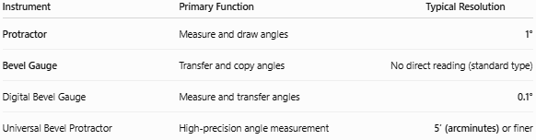
Instrument | Primary Function | Typical Resolution
Protractor | Measure and draw angles | 1°
Bevel Gauge | Transfer and copy angles | No direct reading (standard type)
Digital Bevel Gauge | Measure and transfer angles | 0.1°
Universal Bevel Protractor | High-precision angle measurement | 5′ (arcminutes) or finer

Care and Maintenance
# Source: AI Source: Provided by: [Data Path: Persons Table -> ID Column: 1, Name_En Column: Motasem Essam] -> From: [ChatGPT] on [7/17/2026]
To maintain accuracy:
- Keep the blade clean.
- Tighten the locking mechanism securely.
- Avoid bending the blade.
- Store in a dry place.
- Lubricate the pivot lightly if recommended.
- Calibrate digital models periodically.

Common Mistakes
# Source: AI Source: Provided by: [Data Path: Persons Table -> ID Column: 1, Name_En Column: Motasem Essam] -> From: [ChatGPT] on [7/17/2026]
- Forgetting to tighten the locking screw.
- Allowing the blade to move after setting the angle.
- Assuming a standard bevel gauge displays angle values.
- Misaligning the blade with the reference surface.
- Using a worn or bent blade.

Key Points
# Source: AI Source: Provided by: [Data Path: Persons Table -> ID Column: 1, Name_En Column: Motasem Essam] -> From: [ChatGPT] on [7/17/2026]
- A Bevel Gauge is an angle transfer and layout tool.
- It consists of a handle and an adjustable blade.
- Standard models copy and transfer angles but do not display their numerical value.
- Common types:
  - Standard Sliding Bevel Gauge
  - Digital Bevel Gauge
  - Universal Bevel Gauge
- It is widely used in woodworking, carpentry, machining, engineering, and construction.

Conclusion
# Source: AI Source: Provided by: [Data Path: Persons Table -> ID Column: 1, Name_En Column: Motasem Essam] -> From: [ChatGPT] on [7/17/2026]
A Bevel Gauge is a versatile angle-transfer instrument designed to copy, transfer, and reproduce angles accurately between workpieces. While the standard sliding bevel does not directly measure angle values, it is invaluable for layout and fabrication tasks where the same angle must be repeated. Digital and universal versions extend its capabilities by providing direct angle readings with higher precision, making the bevel gauge an essential tool in carpentry, woodworking, engineering, machining, and quality inspection.

